Directions from Grand City Hotel to Li Ka Shing Faculty of Medicine
- By Taxi
- By Shuttle Bus: A Shuttle Bus will be arranged departing at Grand City Hotel every morning during conference day at 8:00 am.
- If you missed the shuttle bus, don’t panic! There is a bus stop right next to the hotel. Simply wait for Bus 4, 4X, 7, 37A, 71, 90B, 91 or 94 and drop of at Queen Mary Hospital. Follow instructions at posted at “venue” tab and you will be there right away!

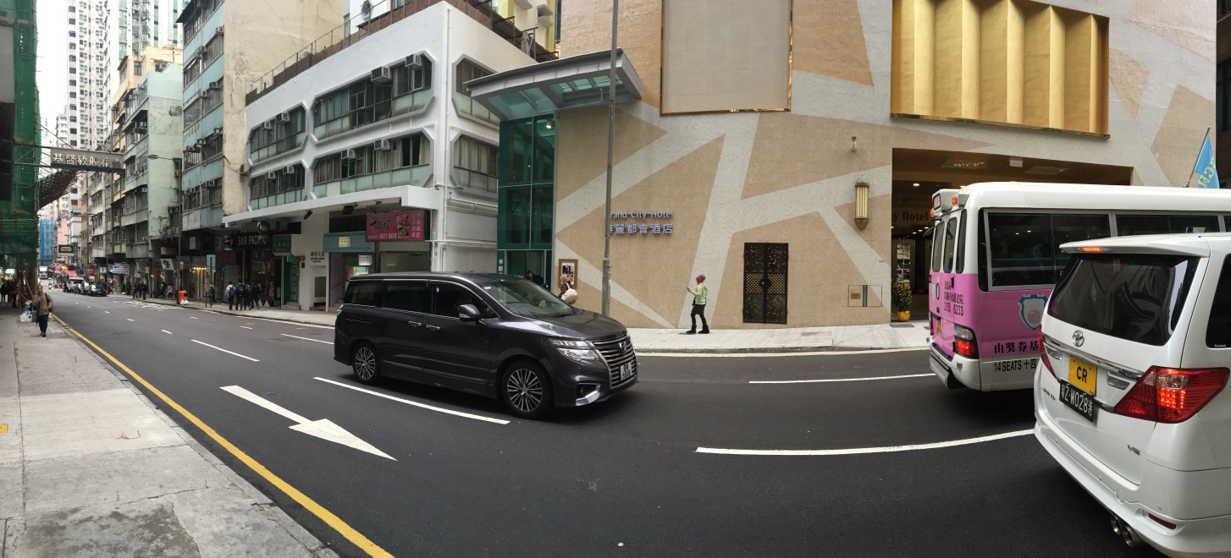
Grand City Hotel
Bus stop
